9/14/2026
Instructor: Sir Mustajab
Submitted by: Wasif Ali
Reg id: 245187
Class: BSCS F24 B


BASICS OF PYTHON
Artificial Intelligence Lab
Lab No 01

Python Code:
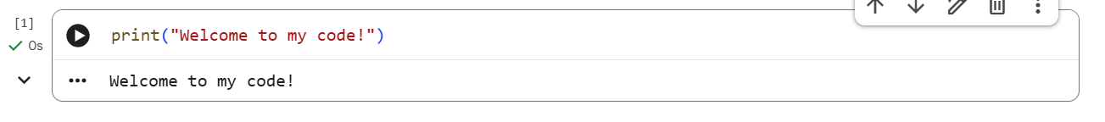
Pseudocode:
START
OUTPUT "Welcome to my code!"
End

Python Code:
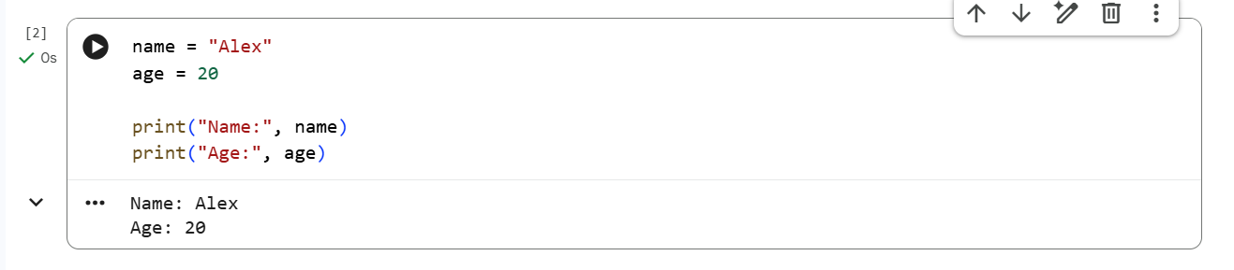
Pseudocode:
START
SET name = "Alex"
SET age = 20
OUTPUT name
OUTPUT age
END

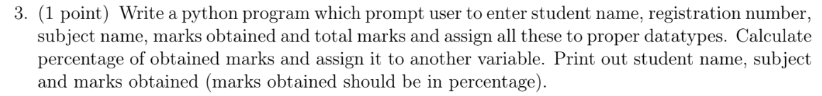
Python Code:
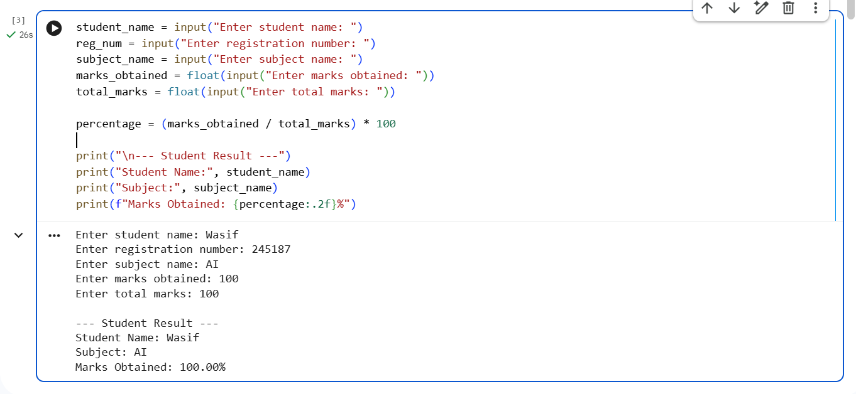
Pseudocode:

START
INPUT student_name
INPUT reg_num
INPUT subject_name
INPUT marks_obtained
INPUT total_marks

SET percentage = (marks_obtained / total_marks) * 100

OUTPUT student_name
OUTPUT subject_name
OUTPUT percentage
END

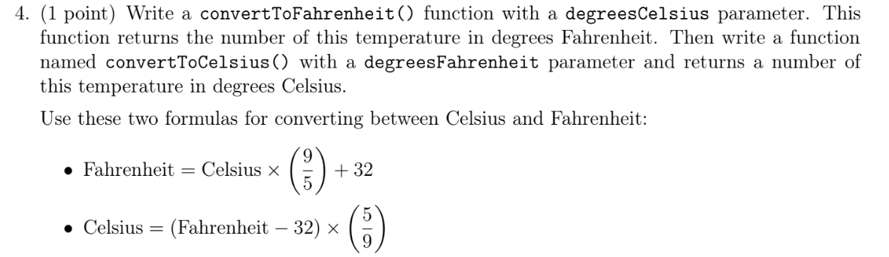

Pseudocode:

START
FUNCTION convertToFahrenheit(degreesCelsius)
RETURN degreesCelsius * (9 / 5) + 32
END FUNCTION

FUNCTION convertToCelsius(degreesFahrenheit)
RETURN (degreesFahrenheit - 32) * (5 / 9)
END FUNCTION

Main
SET resultFahrenheit = convertToFahrenheit(25)
SET resultCelsius = convertToCelsius(77)

OUTPUT resultFahrenheit
OUTPUT resultCelsius
END

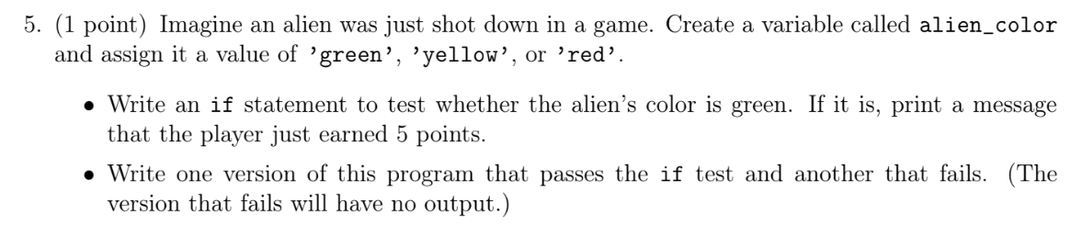
Version 1 (Passes)
Python Code:
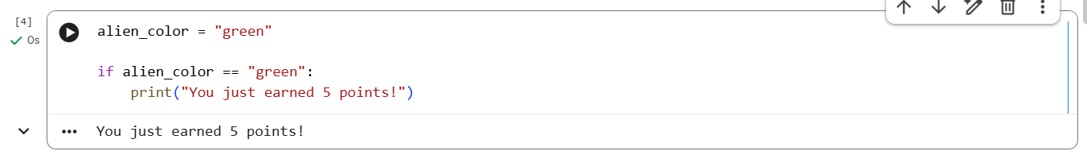
Pseudocode:
START
Step 1: Set alien_color = 'green'
Step 2: If alien_color equals 'green':
Display "You just earned 5 points!"
END

Version 2 (Fails)
Python Code:
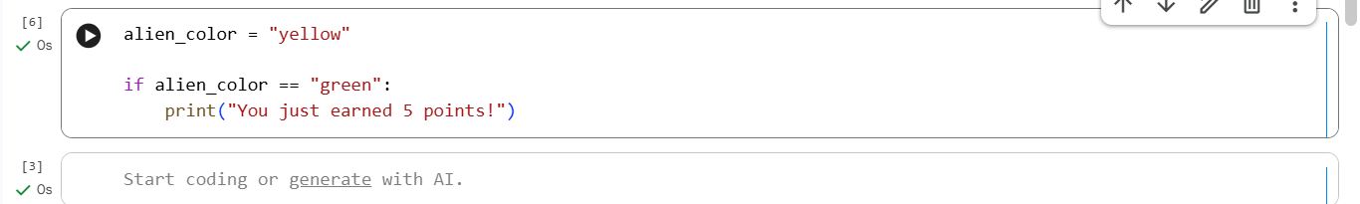
Pseudocode:
START
Step 1: Set alien_color = 'yellow'
Step 2: If alien_color equals 'green':
Display "You just earned 5 points!"
END

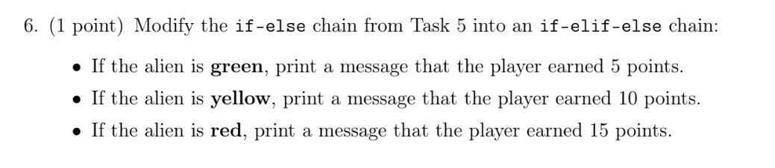
Python Code:
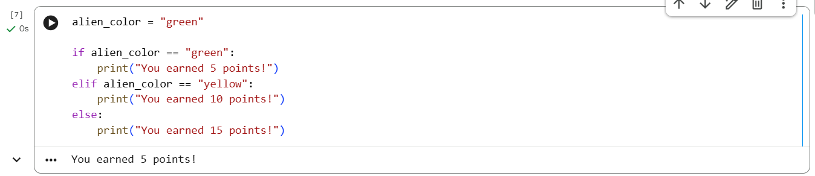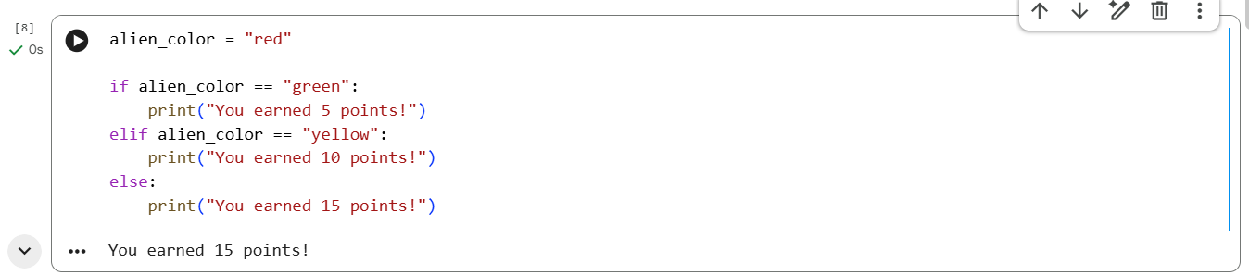

Pseudocode:
START
Step 1: Set alien_color = 'green'
Step 2: If alien_color equals 'green':
Display "You earned 5 points!"
Else If alien_color equals 'yellow':
Display "You earned 10 points!"
Else:
Display "You earned 15 points!"
END

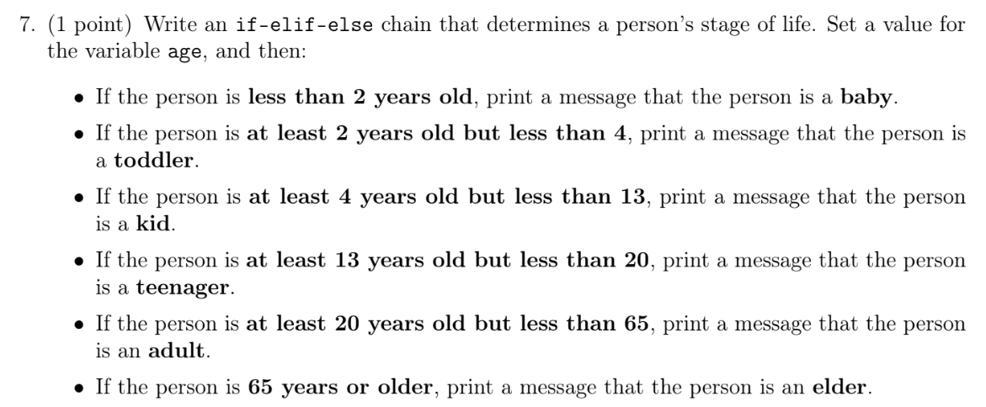
Python Code:
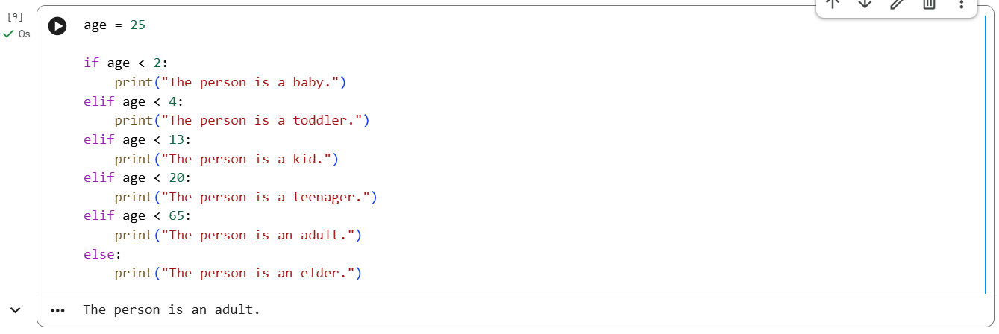
Pseudocode:

START
Step 1: Set age = 25
Step 2: If age < 2:
Display "The person is a baby."
Else If age < 4:
Display "The person is a toddler."
Else If age < 13:
Display "The person is a kid."
Else If age < 20:
Display "The person is a teenager."
Else If age < 65:
Display "The person is an adult."
Else:
Display "The person is an elder."
END

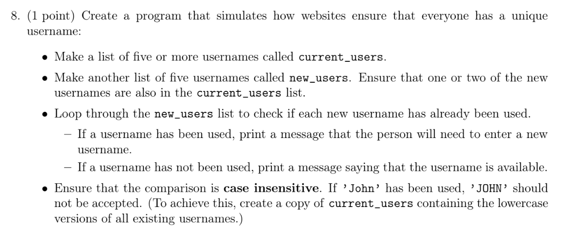

START
Step 1: Set current_users = ["admin", "Wasif", "Anisa", "Hamza", "Zainab"]
Step 2: Set new_users = ["WASIF", "Bilal", "ANISA", "Tariq", "Usman"]
Step 3: Convert all names in current_users to lowercase and save to current_users_lower
Step 4: For each user in new_users:
Convert user to lowercase
If lowercase user is in current_users_lower:
Display "Username is taken. Enter a new username."
Else:
Display "Username is available."
END

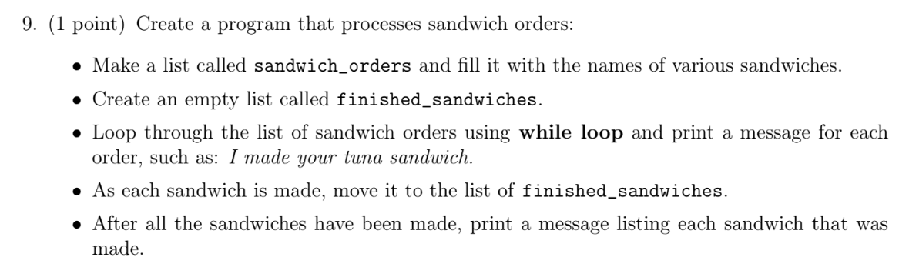

START
Step 1: Set sandwich_orders = ["tuna", "turkey", "club", "veggie"]
Step 2: Set finished_sandwiches = []

Step 3: While sandwich_orders is not empty:
Remove first sandwich from sandwich_orders as current_sandwich
Display "I made your " + current_sandwich + " sandwich."
Add current_sandwich to finished_sandwiches

Step 4: Display "The following sandwiches have been made:"
Step 5: For each sandwich in finished_sandwiches:
Display sandwich
END

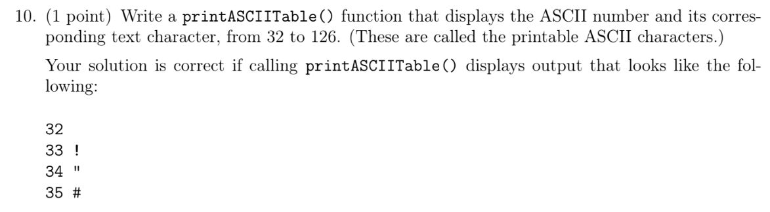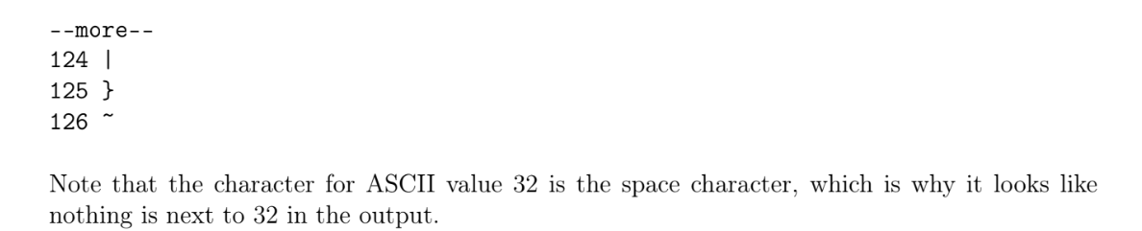

FUNCTION printASCIITable()
For code from 32 to 126:
Display code and CharacterFromASCII(code)
END FUNCTION

START
Call printASCIITable()
END

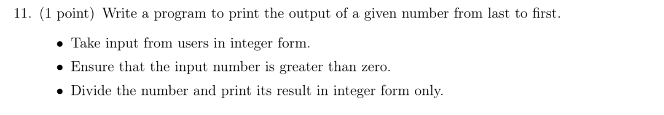

START
Step 1: Input num as integer
Step 2: If num > 0:
While num > 0:
SET digit = num MOD 10
Display digit
SET num = num DIV 10
Else:
Display "Invalid input. The number must be greater than zero."
END

